Install and Configure Tortoise Git

# Install Tortoise Git

Copy TortoiseGit installation from \\ffx-cws-archive\CWS\Software\TortoiseGit

Run TortoiseGit-1.8.9.0-64bit.msi

Follow following steps

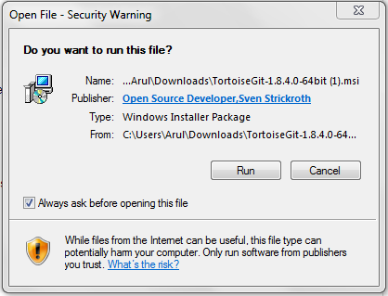

Click on the button Run

The following screen pops up:

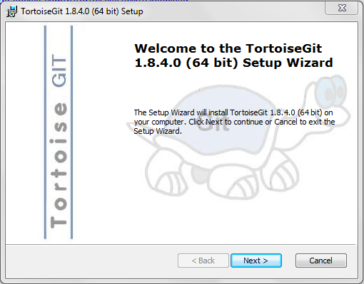

Click the button next

The following screen appears this screen is the user agreement rules:

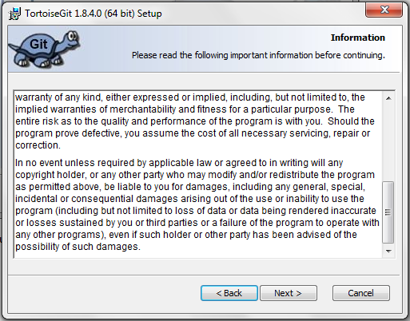

Click on Next button. In the following screen select the first option as shown:

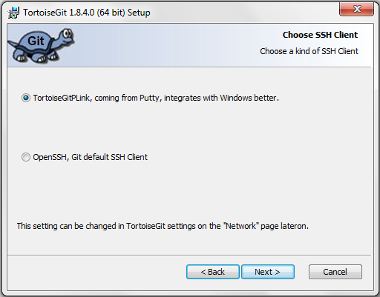

Click on the Next button, the following screen appears. Leave everything as the defult setting.

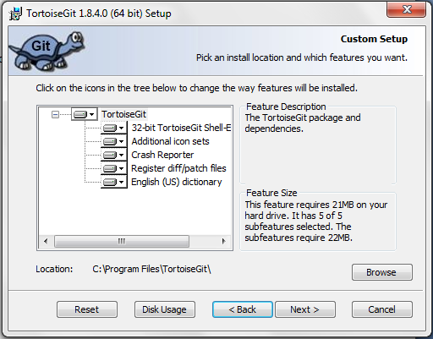

Click on the Next button, following screen appears.

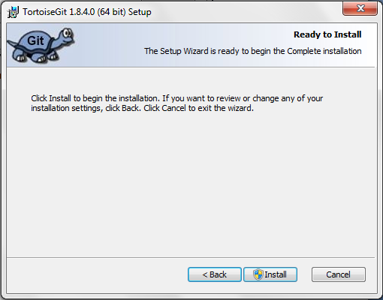

Click on the Install button this will start the process of installing Tortoise Git.

When the installation is finished the following screen will appear:

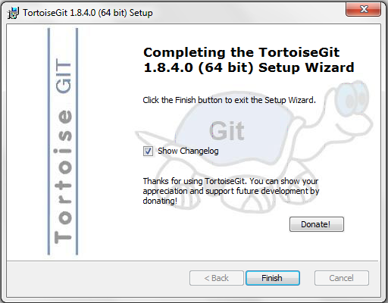

Click on Finish Button

# Install Git

Copy Git-1.9.2-preview20140411.exe from \\ffx-cws-archive\CWS\Software\TortoiseGit

Run Git-1.9.2-preview20140411.exe and install (use default selections)

# Create SSH key

Run Git Bash

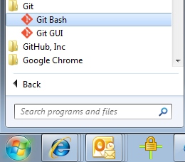

On GitBash command shell type the following

ssh-keygen -t rsa –f gitlabs -C "*your_email@example.com*"

Next, you'll be asked to enter a passphrase.

Enter passphrase (empty for no passphrase): [Type a passphrase]

# Enter same passphrase again: [Type passphrase again]

This should give you something like this:

|  |
| --- |
| Your identification has been saved in gitlabs.  Your public key has been saved in gitlabs.pub.  The key fingerprint is:  64:26:c9:0d:5b:ac:7c:a0:e1:70:7a:bb:ef:2f:5f:c6 hemkumar.balla@cgifederal.com |

# Configure SSH-key on Gitlabs

Open gitlabs.pub file with notepad and copy the content of the file.

Open <https://gitlab.cgifederal.com/> in the browser

Login with your account and click on profile setting icon

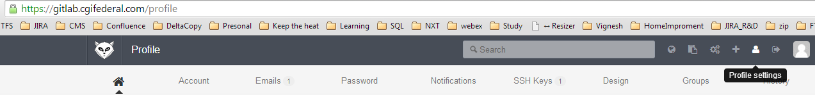

Click on SSH Key menu

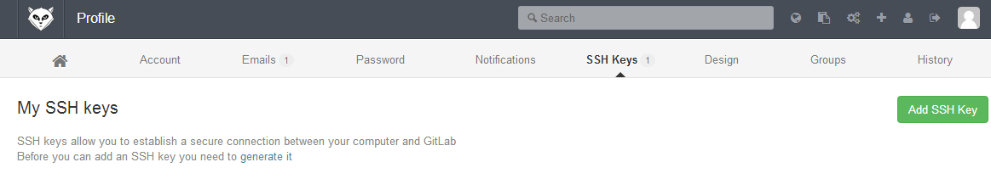

Click on Add SSH Key button and add title and key as shown below and click Add key button.

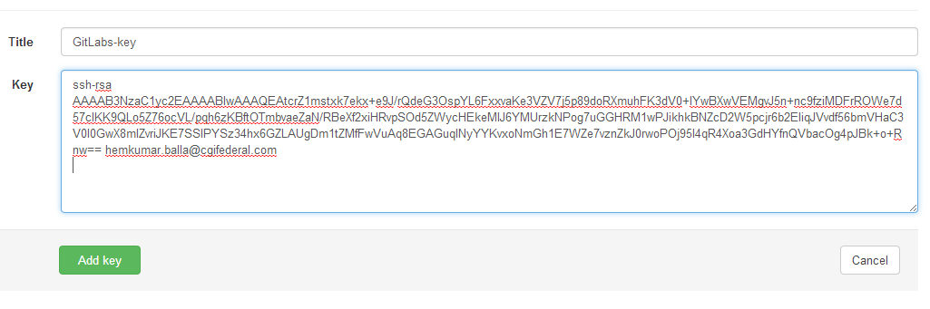

# Configure SSH-Key on Tortoise

Open puttygen

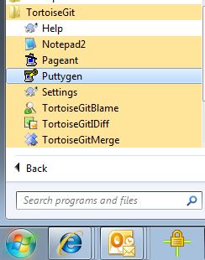

Puttygen will open as shown below.

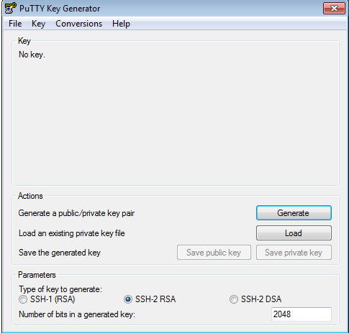

Click on Load button and select gitlabs file which is generated earlier using Gitbash. It will prompt for passphrase, please type the passphrase which you use to create ssh-key in earlier step.

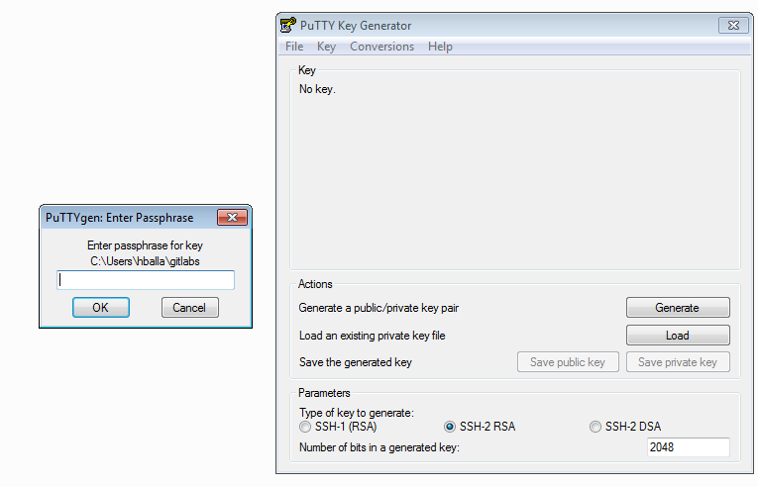

Following successful import dialog shows

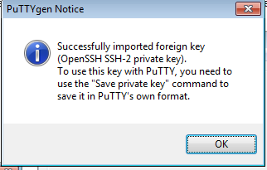

Click on Save private key button and save the file. Close the putty key generator tool.

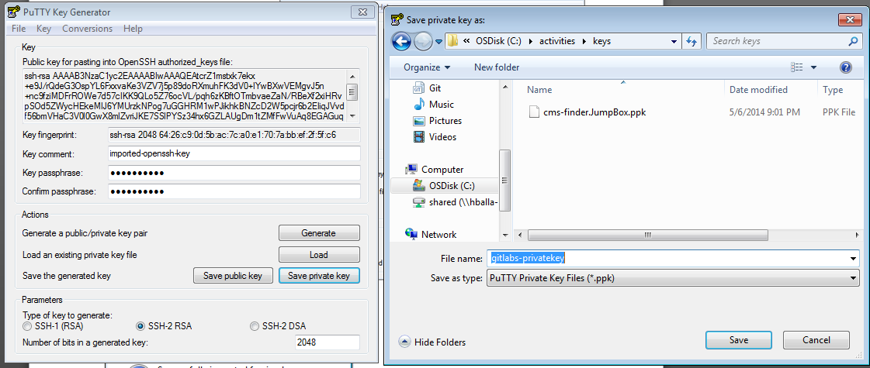

# Clone gitlabs project

Open gitlabs on the browser (if it is not opened)

Get the SSH URL for the project that you want to work as highlighted below.

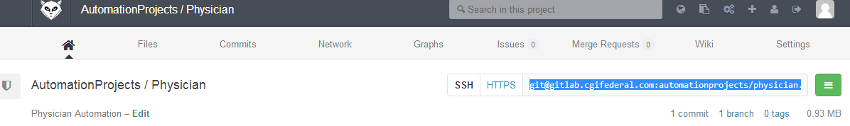

In the above example the ssh url is as below

[git@gitlab.cgifederal.com:automationprojects/physician.git](mailto:git@gitlab.cgifederal.com:automationprojects/physician.git)

Open Explorer and create working directory for example “C:\testscripts\”

Once the directory exist go to directory and right click in the directory will show context menu in which you need to select “Git Clone” menu item.

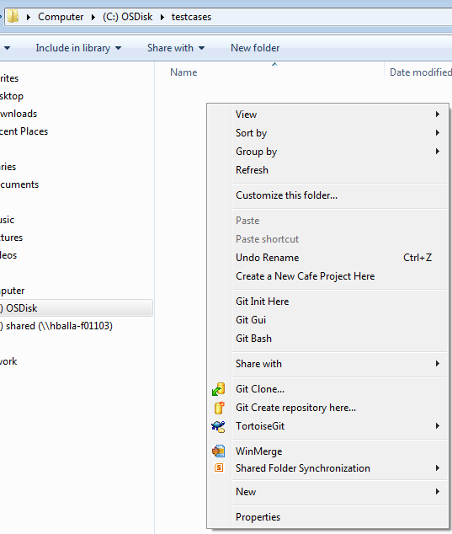

The above step will open Tortoise Git tool

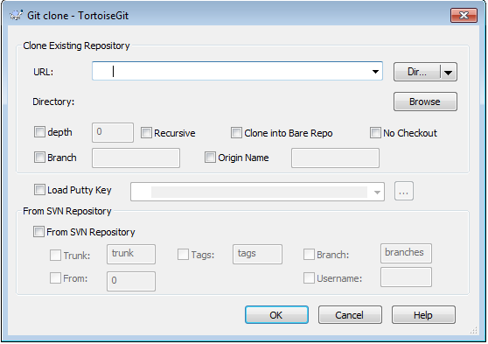

Type or past gitlabs SSH URL you copied from gitlabs site.

Check “Branch” check button and type development

Check “Load Putty Key” and select private key which is saved in earlier step.

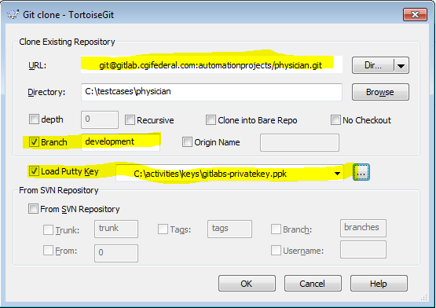

On clicking ok Button it will prompt for passphrase, type the passphrase and click ok button.

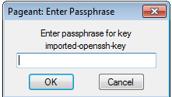

Gitlab project is cloned on your machine, you can modify the file as you normally modify.

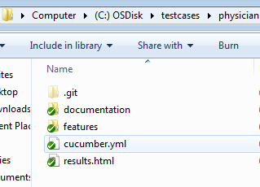

Once modification complete in the following screen I modified results.html file

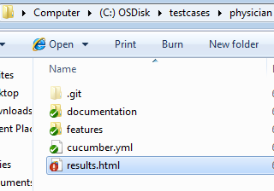

Right click and click on “Git Commit 🡪 development” menu

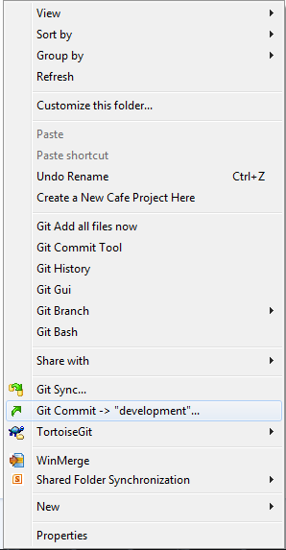

Above step will show the following screen, add commit message and click on “Add Signed-off-by” button

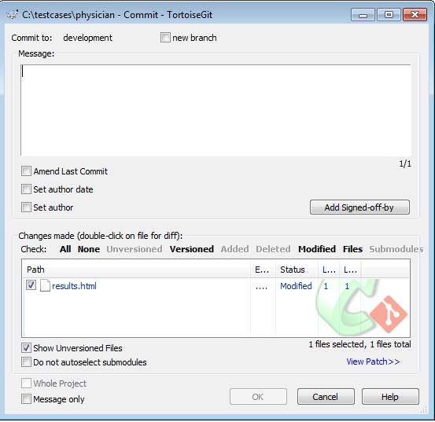

After typing the message, click on ok button.

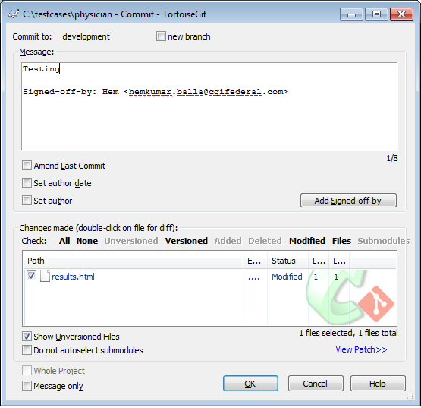

This will show the status of the file committed. Now click on push button will update gitlabs.

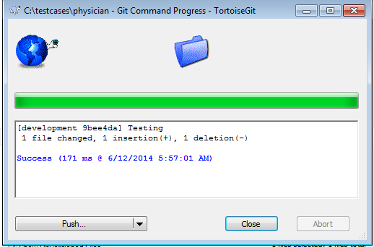

Once you click push the following screen show up click on ok button.

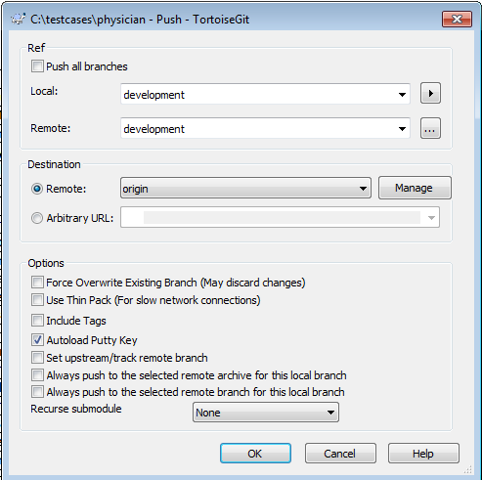

You will get confirmation

